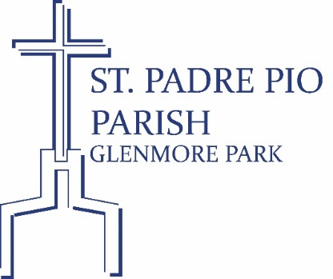
34-38 William Howell Drive (PO Box 8037)
Glenmore Park NSW 2745
Phone: 02 4789 2232 (ext. 4)
Email: sacraments@padrepio.org.au

SACRAMENT OF CONFIRMATION – ENROLMENT FORM 2024
(Please print using BLOCK LETTERS – all information is confidential)

First Name: __________________________________________________________________________

Middle Names: _______________________________________________________________________

Surname: ____________________________________________________________________________

Address: _____________________________________________________________________________

Postcode: _________________________

Date of Birth: _______________________________ Age: __________________ Male / Female

School: ____________________________________________________________Class: ____________

Parish of Baptism: _________________________________ Date of Baptism: ___________________

Father’s Name: ___________________________________ Father’s Religion: ____________________

Phone: _________________________ Email: ______________________________________________

Mother’s Name: __________________________________ Mother’s Religion: ___________________

Phone: _________________________ Email: ______________________________________________

Please attach a copy:

- Baptism Certificate
- Holy Communion Certificate
- Please pay an administration fee of $50.00 via Eftpos/Cash/BPoint
(refer to Parish Website for online payment – www.padrepio.org.au).

Enrolment will not be accepted without these Sacrament Certificates.

Parents / Guardians Commitment and Consent

I/We, the undersigned, as Parents / Guardians of _____________________________ (please print candidate’s name), commit to helping to prepare my/our child for the Sacrament of Confirmation by participating in all the activities and sessions that the Program requires.

I/We understand that involvement in all the Program’s activities/sessions are essential for full preparation for receiving this Sacrament. The commitments include but are not limited to:

- Completion of Enrolment Form Due on Wednesday 24 April 2024
- Attendance at Compulsory Parent Evening Session on 1 May at 7.00 pm
- Attendance at Presentation Ceremony Masses: 4 May at 5.30 pm OR 5 May at 10.00 am
- Attendance at Child Workshops, twice a week and Practice Session throughout May 2024

Father’s signature: _________________________ Current Parish: ____________________________

Mother’s signature: _______________________ Current Parish: _____________________________

Name / Photograph Consent (please circle applicable wording)

I/We consent/do not consent to my/our child’s name and photograph being published in the Parish media such as the Parish bulletin or website and Facebook of St Padre Pio Parish, Glenmore Park, in case this might occur.

Father’s signature: _____________________________________ Date: _______________

Mother’s signature: ____________________________________ Date: _______________

